Lab 1-Soldering Arduino

## Learning Outcomes:

* I know what Arduino is
* I can solder pins onto a PCB

### Background:

### About Arduino:

Arduino is a simple and easy to use hardware and software platform. They are reasonably inexpensive, open source, and easy-to-use. Arduino sells different types of boards which are better for different kinds of projects. Arduino Uno is probably the most popular board.

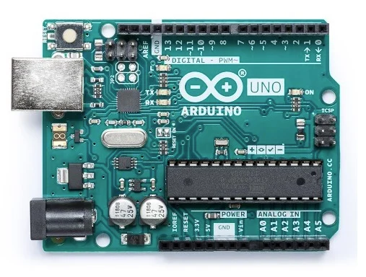

*Arduino Uno. Image courtesy of* [*Arduino*](https://store.arduino.cc/usa/arduino-uno-rev3)

Arduino Uno has a 16MHz Atmega328 processor, 2KB of RAM, 1KB of EEPROM, 14 digital I/O, 6 analog inputs, and 5V and 3.3V power rails. We can use the analog inputs to read data from an analog sensor or output a signal. We can use the digital I/O pins to read or write from digital sensors. EEPROM and RAM are different kinds of storage/memory that the Arduino uses to store the program we upload to it. The processor is the brain of the computer. It reads and executes the instructions stored in memory.

The board that we’ll be using is a shrunken version of Arduino Uno called Arduino Nano.

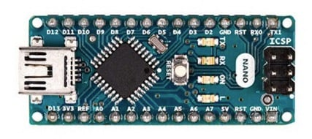

*Arduino Nano. Image courtesy of* [*Arduino*](https://store.arduino.cc/usa/arduino-nano)

Because of it’s smaller size the Arduino Nano is better fit for some projects where space is a concern.

Arduino boards are based on a component called a microcontroller. The specific microcontroller for the Arduino Nano is typically an ATmega168 or ATmega 328. It’s the black square in the picture above. Microcontrollers are different from microprocessors. A microcontroller is optimized to perform a specific task over and over again. However, it is not like a computer, which uses microprocessors, that can perform a variety of tasks. (More on the difference between microcontrollers and microprocessors [here](https://www.guru99.com/difference-between-microprocessor-and-microcontroller.html)) This means when we upload code to our Arduino it will run that code forever until it dies or we cut the power.

The objective for today’s lab is to 1) solder pins onto our Arduino Nano.

### Step 1 Soldering Arduino Nano:

The Arduino you received probably doesn’t have pins attached quite yet. The method we use to attach them is called soldering.

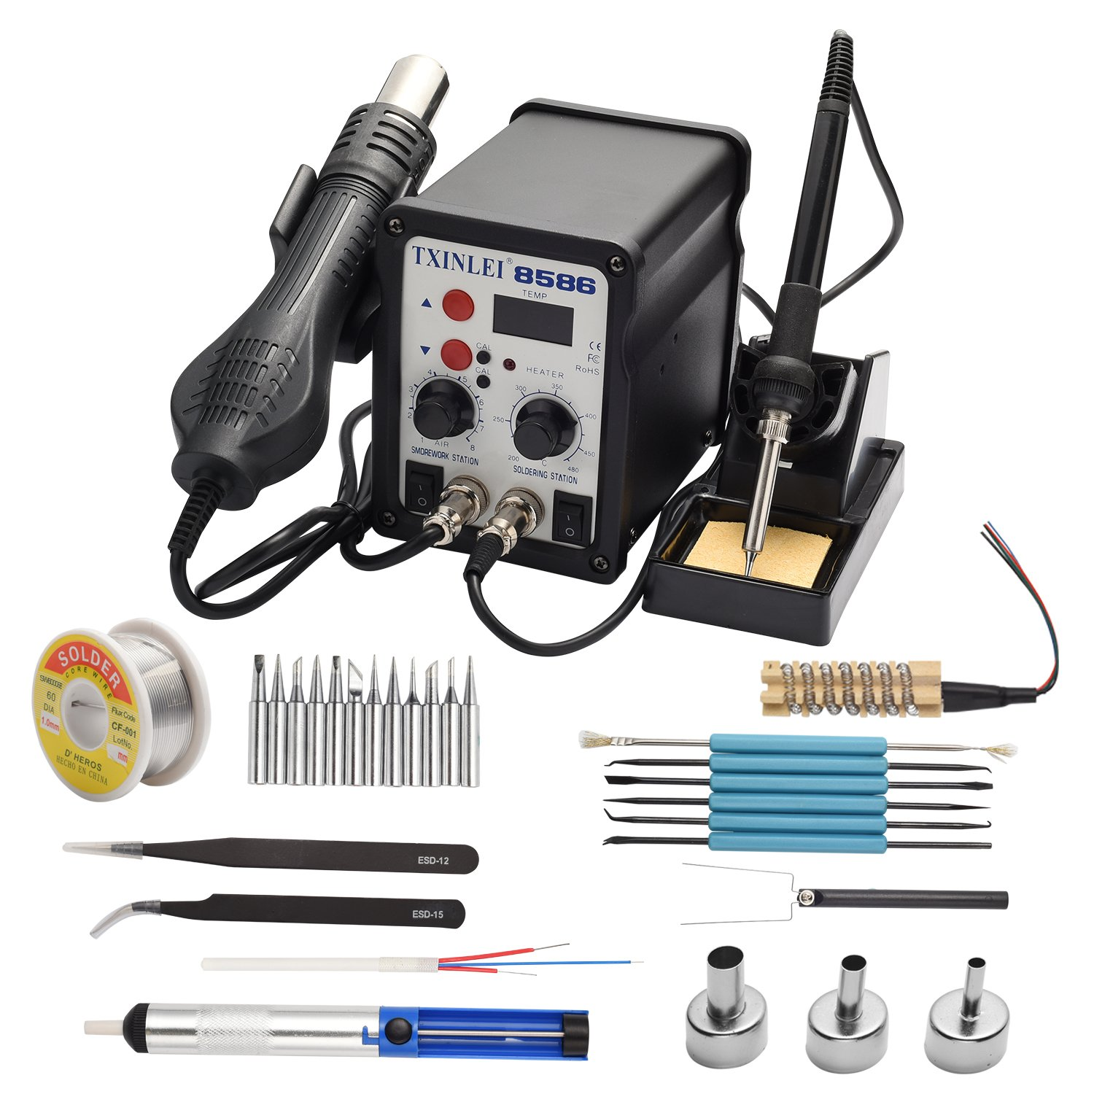

*Soldering Station. Image courtesy of* [*Amazon*](https://www.amazon.com/TXINLEI-8586-Soldering-Different-Desoldering/dp/B07FJ6PNHF)*.*

Soldering is the process of joining two metal parts together using a metal filler. Solder is what we call the metal filler we melt and flow to join the parts together. It might help you to think of the solder as the glue that holds the two parts together and the soldering iron as a hot glue gun.

#### Tools and Materials:

To solder our Arduino Nano we will need

1. the components we want to solder (ie Arduino Nano and pins)
2. soldering wire
3. a soldering iron
4. a fan or well-ventilated area

#### Safety:

CAUTION: It is important that you follow the proper safety procedures to not harm yourself or others!

* Don’t touch the tip of the soldering iron while it is hot. Return it to the stand when you are finished soldering a component to avoid accidentally touching it.
* Work in a well-ventilated area and use a fan to avoid ingesting smoke from the solder. The smoke coming off is from the flux in the solder and can be quite irritating to breathe.
* Solder usually contains lead, which is poisonous. Don’t eat or drink while soldering. Wash your hands after using solder.

#### Soldering:

Start soldering by first making a mechanical connection between the two components you want to solder. This means to hold them in place before trying to apply the solder. Use your helping hands to assist with this.

Next heat the components with the tip of your soldering iron before trying to apply the solder. When the connection is hot, push the soldering wire into the joint. The solder should melt and bind to the parts. Don’t melt the solder and then try to apply it to the joint. It will not work. You want the solder to bind to the Arduino Nano and the pins. If you do it improperly you might have a poor joint which won’t allow electricity to flow.

#### Tips:

* You can apply a small amount of solder to the tip of your iron before heating the joint. This is called tinning and will help the heat conduct better.
* Use a small amount of solder each time. It’s easier to add solder than to take it away. If you do end up using too much you can remove solder using a desoldering gun.
* Check continuity as you go along. There is nothing more frustrating than soldering a bunch of components and then finding out there’s a short somewhere but you don’t know which component it might be.

#### Extra Materials:

Please read/watch these extra materials before soldering. It will really help you to do a better job and avoid having to desolder a shorted Arduino Nano.

https://www.youtube.com/watch?v=wDbUChzxIrE

<https://www.sciencebuddies.org/science-fair-projects/references/how-to-solder#soldering>

<https://www.youtube.com/watch?v=Qps9woUGkvI>

https://www.youtube.com/watch?v=ckWVNQ4Ci4A

<https://www.youtube.com/watch?v=KbTcO1vWDnc>

Once you’re done soldering the pins the finished Arduino Nano should look something like this:

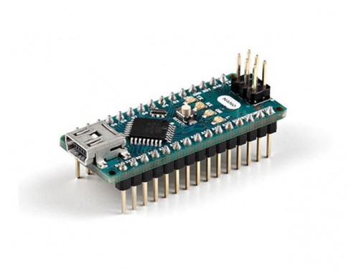

*Finished Arduino Nano. Image courtesy of* [*Arduino*](https://store.arduino.cc/usa/arduino-nano)